Business Communication: In Person, In Print, Online
9e
INSTRUCTOR’S GUIDE
Chapter 1 |  | Understanding Business Communication
Overview
The communication process begins with a need, and the sender interprets the context, identifies and analyzes the audience, determines objectives, chooses the medium, and creates the message. The audience interprets the message and provides feedback, creating a new message.
The communication process travels within formal and informal networks. Communication is challenging when interrupted by verbal or nonverbal barriers.
Audience and communication objectives play an important role in selecting communication media for a message. Both oral and written channels include traditional and technology-based media, such as social media, corporate blogs, and others.
To avoid legal consequences of communication, employees follow company guidelines and use common sense. Effective communicators also follow professional, social, and individual ethics.
Learning Objectives
- Identify the components of communication.
- Identify the major verbal and nonverbal barriers to communication.
- Describe criteria for choosing communication media.
- Avoid potential legal consequences of communication.
- Communicate ethically.
Quick Links for Chapter 1
PPT Slides | Solutions to Exercises | Handouts | Video Suggestions | Company Examples | BizCom in the News
Teaching Suggestions
Resources |  | LO1: Identify the components of communication.
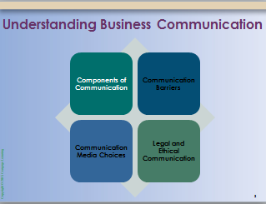 |  | INTRODUCE the concept of business communication. Highlight the importance of communication for any job—the substantial rewards of effective communication and the risks of communication failures.
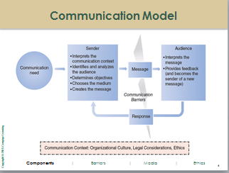 |  | DISCUSS the major components of communication. Clarify that the process is not linear and could involve divergent steps—it’s not a perfect model.  14-week business: Ask students for examples of communication they received at a recent job, and then walk through the components of communication with these examples.  14-week non-business: Ask students for examples of communication they encountered in various business-related situations (e.g., as customers) and then walk through the components of communication with these examples.

Resources |  | LO2: Identify the major verbal and nonverbal barriers to communication.
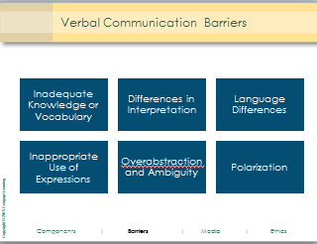 |  | INTRODUCE the verbal barriers to communication, and invite students to share their opinions about the impact these barriers may have on communication. Use the following discussion starters:  - Which of these verbal barriers do you find most damaging to communication?  - From your experience, have you seen examples of barriers interfering with communication?  - What is the best way to overcome these barriers?
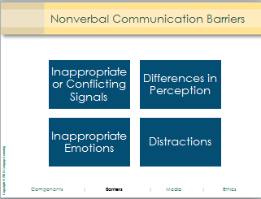 |  | FACILITATE a discussion about non-verbal barriers to communication.  INSTRUCT students to work in teams. Invite them to do the following tasks:  - Discuss distractions. In what ways do you multitask? What is helpful and potentially harmful about the way you multitask?  - Brainstorm a list of solutions (e.g., turning off Facebook alerts). Which can you apply to the way you work?
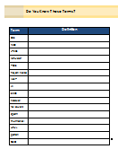 |  | DISTRIBUTE the handout “Do You Know These Terms?” and ask students to define each term:  Term Definition  OS Operating system  FAQ Frequently asked questions  JPEG Joint Photographic Experts Group (compression technique for color images)  retweet Sending tweets others wrote on Twitter  POS Point-of-sale  Trojan horse Malware that appears to perform a desirable computer function but instead attacks a computer system  VoIP Voice over Internet Protocol (used for making Internet phone calls)  AI Artificial intelligence  SEO Search Engine Optimization  hacker Person who breaks into computers and computer networks  followers Twitter users subscribing to receive others’ updates  spam Use of electronic messaging systems to send unsolicited bulk messages  thumbnail Reduced-size versions of pictures, used to help in recognizing and organizing them  HTML HyperText Markup Language  patch A quick fix for a programming defect  CAD Computer-aided Design
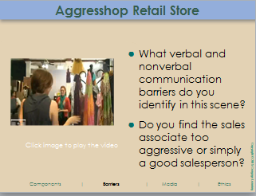 |  | INSTRUCT students to work in teams, and show the Aggresshop Retail Store video. Invite students to discuss the questions from the PPT slide in their teams first; then have them share their team’s opinion with the rest of the class.

Resources |  | LO3: Describe criteria for choosing communication media.
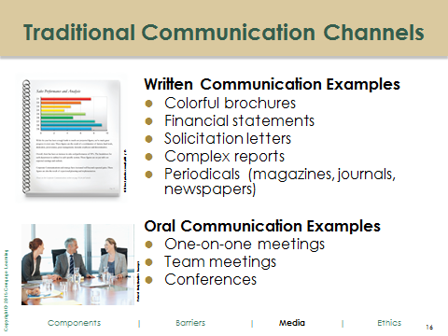  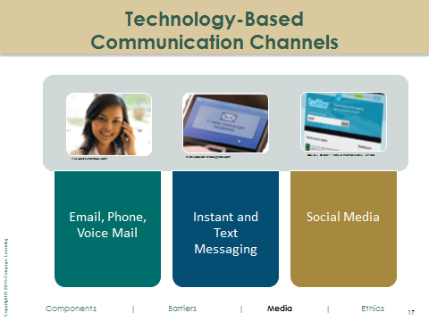 |  | INTRODUCE the communication media classifications: oral and written channels, traditional and technology-based media. Invite students to identify various media types on a white board or large paper; ask them to illustrate the use of each media type with examples from their professional or personal experiences.
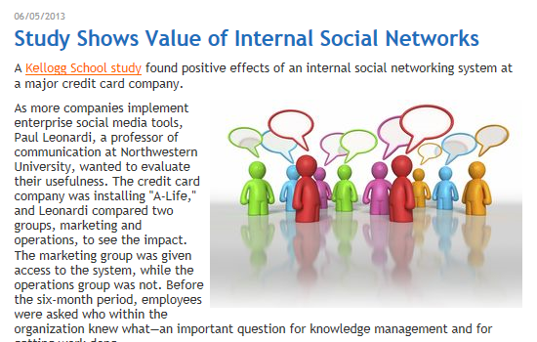 |  | 14-week business: INTRODUCE the story, “Study Shows Value of Internal Social Networks,” on www.bizcominthenews.com.  Discuss the study and ask students to share their experiences working for organizations. Have they had access to internal social networks, such as Yammer? What has been their experience? In what ways did the network help and hinder their work?
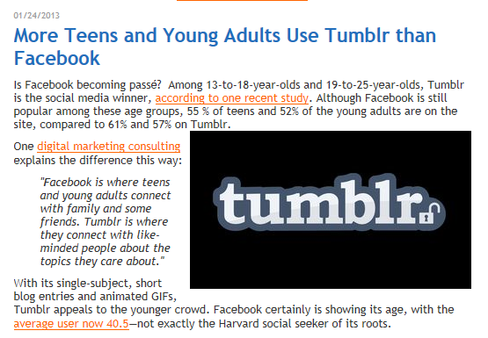 |  | 14-week non-business: INTRODUCE the story, “More Teens and Young Adults Use Tumblr than Facebook,” on www.bizcominthenews.com. Facilitate a discussion comparing social media sites, such as Facebook, Tumblr, and Twitter. How are students using each? Which are most valuable for which business purposes?
 |  | 14-week non-business: SHOW Up in the Air video clip (send email to amynewman@cornell.edu for the clip). Discuss with students the possibility of using videoconferencing to announce layoffs.

Resources |  | LO4: Avoid potential legal consequences of communication.
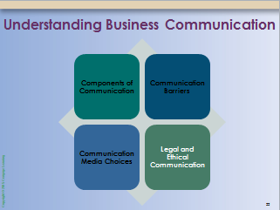 |  | INTRODUCE the concept of legal consequences of workplace communication. Address the idea of private vs. public communication, information access, copyright and proprietary information, etc., as students’ understanding may be very limited.
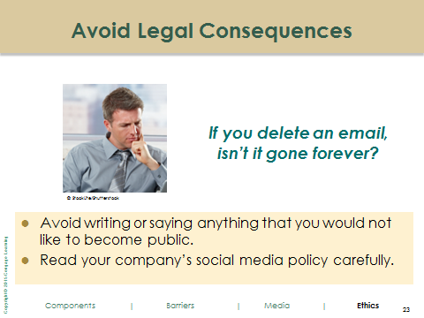 |  | REFER TO the PPT slide with a question for students: “If you delete an email, isn’t it gone forever?” Invite students to brainstorm all possible locations for a deleted email; write their answers on the board. Possible answers may include the following:  - In a deleted folder or trash  - On a computer server for retrieval by special programs  - In the recipient’s inbox  - In the recipient’s deleted folder or trash  - On the recipient’s computer server  - In forwarded recipients’ inboxes, deleted folders, or servers  - In print  - On many websites, including social networking sites
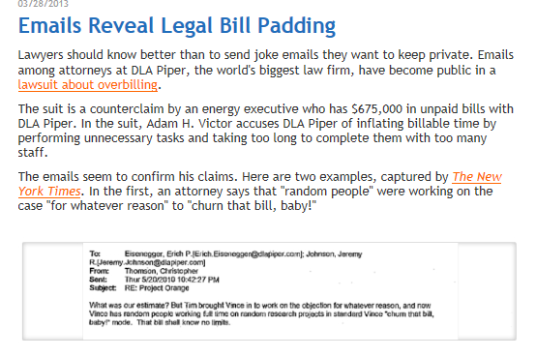 |  | 14-week business: REFER TO the story, “Emails Reveal Legal Bill Padding,” on www.bizcominthenews.com. Invite students to complete the following:  Imagine that you are the chief legal officer of a major company. Write an email to all employees to reinforce your communication policy. How can you remind people to protect their email and other communications?  Potential answers to the last question may include the following:  - Don't release confidential information or anything without prior approval from the source.  - Use professional and respectful communication, without slurs, insults, foul language, etc.  - Remember that any content posted may become visible and public.

Resources |  | LO5: Communicate ethically.
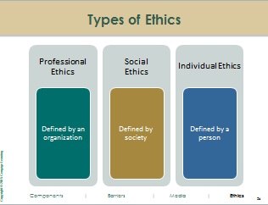 |  | INTRODUCE the concept of ethical communication; discuss how professional, social, and individual codes of ethics may impact our communication decisions at a workplace. Invite students to share their knowledge of companies’ corporate social responsibility (CSR) efforts. (For example, students may have noticed oil companies’ advertisements or displays at stores such as Starbucks.)
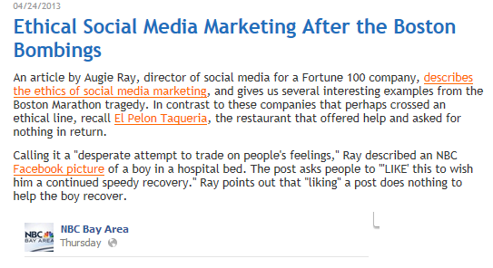 |  | INTRODUCE the story, “Ethical Social Media Marketing After the Boston Bombing,” on www.bizcominthenews.com.  14-week non-business: Invite students to discuss the ethical implications of the situation. Use the following discussion starters:  - What do you think of these situations? Looking at the images posted, do you think the campaigns are potentially unethical?  - What else could these companies have done to show their support for victims of the bombing? Be creative: think of social media and other opportunities.  14-week business: Using the same story, have students complete the following:  Write an email to the CEO of NBC explaining your position on the topic. Have students choose: either urge the company to change the campaign or show support for their efforts.
 |  | REFER TO the story, “George Takei’s Ghost Writer Fesses Up,” on www.bizcominthenews.com. Have students debate whether this situation is unethical. Encourage them to consider when paying for tweets or Facebook posts may cross an ethical line.
14-week business: INVITE students to work in groups to talk about their experiences at work. Pose the following questions:
- If you uncovered wrongdoing at work, what avenues would you take to report the issue?
- What resources may be available within your company?
- What are the advantages and disadvantages of using these internal channels first?
Solutions to Exercises
3Ps in Practice: Media Choice to Communicate a Decision
Process
- What do you want to achieve with your message? Consider both short- and long-term objectives.
I want to come to a compromise with my boss. In the short-term, I would like to convince her to abandon the campaign. In the long-term, I want her to see that our company shouldn’t encourage negative body images. In an ideal situation, we will have a more positive series of slogans on T-shirts and other apparel, whether it concerns body image or not.
- Why are face-to-face meetings (a rich medium) most commonly used for difficult discussions?
Face-to-face meetings are most commonly used for difficult discussions because they permit open communication, show body language, and allow for immediate responses. Having a difficult discussion in a one-way form of communication, such as an email or a letter, leaves a lot up to interpretation.
- What criteria will you use to determine the best communication medium for your message? Consider using multiple formats (e.g., email, a meeting, or a report)—perhaps for different points or objectives.
I am having a difficult discussion with my boss to tell her that I won’t do a job that she asked me to do. The sensitivity of the situation drives my decision as well as the logistics of whether we can meet in person.
- What medium or media will you use for your message(s) to your manager? Why did you choose each option?
Because I am delivering negative feedback to my boss’s suggestion, a face-to-face medium would be the best way to deliver this message. One thing we must consider is that she sent the request to me via email. The best option may be to schedule a time to meet with her via email; then, we can talk in person.
Product
Student responses may vary, but here is one example:
To prepare for the face-to-face meeting, I will outline my reasoning for wanting to abandon the campaign. I will research concrete examples to illustrate that similar campaigns have backfired. I will have an alternative campaign to propose to my boss, whether about body image or not, to better reach the target market. I will make it clear to her that her idea is not one that I am ethically comfortable with, and I’ll think about questions that my boss may ask to prepare answers for them. She could respond negatively, but by allowing open dialogue (asking questions, receiving answers), I will try to convince her to steer away from this idea.
- Identify communication components in a current news story.
Students are encouraged to select a news story of interest and identify the communication need, sender, message, audience, and response. Students may reference www.bizcominthenews.com to find a recent story.
Following are examples of the communication components involved in the news story “Try Protein Instead of Meat at Taco Bell” (June 26, 2013).
Communication Need: The idea of “meat” has gotten a bad reputation.
Sender: Taco Bell’s marketing department
Message: Taco Bell offers “protein,” not “meat.” Protein is associated with healthy and delicious food; on the other hand, meat is associated with unhealthy eating. One medium to communicate this message may be the menu (i.e., offering options on the “Power Protein Menu”).
Audience: Customers of Taco Bell
Response: Customers may be more excited to try the “protein-related” items on the Taco Bell menu. Concerns about mystery meat and pink slime may decrease as the company uses the word protein in lieu of the word meat.
- Examine your own communication filters.
This exercise asks students to identify how they personally filter information. Have students think critically about how their experiences, culture, emotions, personality, knowledge, socioeconomic status, and demographic variables affect their interpretation of messages.
- Create an organization chart to identify a company’s formal communication network.
Students should diagram an organization chart similar to that in Figure 3 (Starbucks) that demonstrates the levels of employees. Students should draw on their chart the directions of communication within the organization. Have students identify the different forms of formal communication:
- Downward communication: information flows from a manager to his or her employees.
- Cascading communication: information flows from one level down to another.
- Upward communication: information flows from lower-level employees to upper-level employees or managers.
- Lateral (horizontal) communication: communication flows among peers.
- Describe a company’s grapevine.
Encourage students to analyze the informal communication network of the company they discussed in Exercise 3. Ensure that students discuss both possible positive and negative aspects of the grapevine. Management should have an understanding of the company grapevine and be able to respond. Have students evaluate management’s involvement in the grapevine.
- Identify communication barriers between a manager and an employee.
Students may identify the following verbal and nonverbal barriers in the scene from the movie Office Space. (See Videos for Chapter 1 on bizcominthenews.com.)
Verbal Barriers
- Difference in Interpretation: Although Stan asks Joanna to “express herself in flair,” she thinks that it is sufficient to wear only the minimum 15 pieces of flair. Stan would actually like her to wear more flair than the minimum. He should change his communication to state that he would like her to wear more than 15 pieces. By leaving the interpretation up to Joanna, Stan miscommunicates.
- Ambiguity: Stan does not directly tell Joanna what he is thinking and what he would like Joanna to do. Instead, he talks about people who only do the bare minimum and uses other servers as examples. He could have been more effective if he had used more concrete language, referring specifically to Joanna.
- Polarization: Stan views flair as an all-or-nothing situation. Either you have lots of flair and care about your job, or you have no flair and don’t care about your job. His servers are on either end of this spectrum.
Nonverbal Barriers
- Conflicting Signals: The way Stan carriers himself makes it seem as if he really wants the employees to make the decision on her own. He shrugs his shoulders, looks around, and speaks in a soft voice. He is conveying a serious message, but seems rather condescending about the subject.
- Differences in Perception: Stan and Joanna perceive the purpose of flair differently. Stan thinks that everyone should love getting to wear flair, and Joanna thinks it is a nuisance and does not like it. Stan needs to be clearer about the purpose of flair at Chotchkies.
- Inappropriate Emotions: Stan is very apathetic and not clear about what he wants Joanna to do. He looks impatient at times, with exaggerated eye movements.
- Identify communication barriers between a retail sales representative and a customer.
Note: This video is part of the “Aggresshop” company scenario (www.bizcominthenews.com/aggresshop). The video is embedded in the instructor’s PPT.
Communication barriers between the sales associate and the shopper made for an unpleasant shopping experience. The most obvious barrier is nonverbal: the customer does not make eye contact and turns her body away from the sales associate. Instead, she could be clear: “Thank you for your help, but I would rather just browse on my own for a while.” At the end of the interaction, the customer asks for an item to distract the associate so that she can run out of the store. She could have handled this differently (although, of course, the associate should have paid attention to nonverbal cues).
Much of their communication failures stem from the different goals of the two individuals in this interaction. The sales associate has been trained to sell items to each individual in the store. She wants to be helpful and available to assist the shopper in any way possible (to get a high commission!). Although the shopper seems disinterested in the associate’s suggestions, the associate continues to recommend new items and provide commentary on what the shopper is doing. The sales associate may perceive the shopper’s disinterest as dissatisfaction with the merchandise, so she hopes that additional suggestions and commentary may lead the shopper to an item she wants to purchase.
The shopper, however, finds the sales associate overbearing and just wants to browse. She avoids the associate, does not make eye contact, and continues to be dismissive. Although the sales associate intends to be helpful and friendly, the shopper finds her annoying and leaves the store as a result.
- Identify communication barriers in an episode of Mad Men.
Students will identify examples that demonstrate verbal or nonverbal communication barriers.
- Discuss communication barriers.
Student responses may vary depending on opinions; however, one answer could be that verbal communication barriers are easier to overcome because you can study language and slang, but it’s really difficult to hide natural reactions and body language.
- Adapt jargon for your audience.
Student responses will vary based on the topic they choose to discuss. Below is an example set of emails about baseball sent from one friend to another.

To: Christina Parker
From: Jon Brown
Subject: Last Night’s Baseball Game
Hey Christina,
Did you happen to see the game last night? It was incredibly action-packed. When the Yankees had bases loaded and the next player was at bat, I was hoping for a home run, a grand slam, but then they grounded into a double play! How disappointing.
I hope tomorrow’s game is better.
Jon

To: Jeremy Toffer
From: Jon Brown
Subject: Last Night’s Baseball Game
Hey Jeremy,
Did you happen to see the game last night? It was incredibly action-packed. At one point, the Yankees had a player on all three bases, and one more player had his turn to bat. I was hoping that he would hit the ball far enough so that he could run around all four bases because then the Yankees would score four runs with one hit—one for each player on base plus the batter. But we hit a ground ball, yielding outs at both second and first base. How disappointing.
I hope tomorrow’s game is better.
Jon
Students should note the following:
- Jargon tends to shorten emails.
- Jargon is more effective only when the reader fully understands; otherwise jargon will have a negative effect (misunderstandings and possibly bad feelings).
- Analyze print communication.
Students should use print media from around the campus to analyze. Posters or “quarter card” advertisements are some examples. Print media can make a different impact on individuals than technology-based media. Students should evaluate the effectiveness of the print media and whether a digital form should be used as a supplement or a replacement. With their experience online, students should have no trouble identifying alternatives for print: websites, Facebook, Twitter, etc.
- Explore how a company uses social media.
Students should thoroughly examine the use of social media by their favorite company. The form of social media, the frequency of posts, the purpose of the posts, and the connections among forms of social media are important aspects of a company’s social media strategy. Some companies may be prompted to improve their social media management because of their competitors’ use of social media. Students may find it interesting to see how companies in different industries (e.g., hospitality, technology, finance, retail, not-for-profits) use social media. Students should attend class prepared to discuss their findings with other students.
- Choose communication media for different audiences.
Media choices may include the following:
Audience | Communication Medium (or Media) | Rationale for Choosing the Communication Medium
Store managers | Email  Phone follow-up | I would send an email to my 16 store managers to communicate why we need to close the stores and how they should communicate this news to their employees and clients.  I would follow up with individual phone calls to answer any questions that the managers still have and to make sure they are ready for the redesign and to be closed for two weeks.
Store sales representatives | Meeting | I would ask the managers to meet with their sales associates in person. At the meeting, the managers will communicate the news and explain the procedure for the weeks leading up to and during the closure. This will allow sales associates to ask questions and get an immediate response. Sales associates are all located at the store, so an in-person meeting is easy, but the sales managers may need to hold more than one to accommodate different shifts.
Corporate office employees | Email  Meeting | I would initially email corporate office employees explaining the process for the redesign and how the company as a whole would be affected. I would also explain how to respond to customer questions and concerns.  Additionally, I would invite all corporate employees to an optional meeting to review more details and answer questions. This will allow me to answer particular questions and address concerns.
VIP customers | Personalized letter | Each VIP customer would receive a personalized letter so they feel appreciated and that the company cares about their VIP status.
Other customers | Letter or email  Sign on stores | All customers should receive a generic letter or email explaining why the store is closing and when it will reopen. If managers have customers’ email addresses, then an email should be sent; otherwise, a letter may be sent to a home address.  In addition to the direct communication, managers should post signs on all store windows for customers who drop by. This should be a standardized poster that the corporate office creates and sends to all stores.
Suppliers | Letter or email | All suppliers should receive a letter or email from the company explaining which stores will be closed and when so they can adjust their deliveries accordingly.
- Choose how to reject a job offer.
Facilitate a discussion about the best medium choice. If students are offered a position over email, then email is an acceptable way to respond. If the job was offered by phone, then students should call back to decline the offer. If the employer had taken the time to call instead of email, then it is appropriate to respond “in kind.”
- Give your manager advice about communication media.
Students may write an email such as the following:

To: Larson James
From: Kendra Simpson
Subject: Re: Confidential: Move to Itasca
Larson,
Thank you so much for telling me about the transition to Itasca—I won’t sign the lease!
Many of the other employees in our department will not be pleased with this transition. You mentioned that you will send an email to everyone, but would you consider holding a face-to-face instead? This way, you can explain the reasoning behind the move and answer any questions.
Employees will want to have a clear understanding of why the department is moving and how that will affect them. Additionally, many of them will need to relocate families, which might be difficult, and they will appreciate hearing this in person. With big change comes many questions. I anticipate employees asking a significant number of questions, and questions will be answered more effectively during a meeting. This will allow individuals to get a response immediately and will keep you from having to respond to many of the same emails.
Thanks again for letting me know,
Kendra
- Research a lawsuit about communication.
Students can search online to find a possible lawsuit example. Students’ analysis of the questionable communication should be directed towards the correct audience—a competitor to the company in question. As students identify flaws in the company’s behavior, they should brainstorm advice for avoiding a similar error in the future.
- Write a policy about email use.
Students should address the following issues in their policy about email use: why a policy is necessary, what the different rules are, what the consequences are for people who don’t follow the policy, and how to contact the person in charge of the policy. Below are links to two examples of email policies:
http://humanresources.about.com/od/policiesandsamples1/a/email_policy.htm
http://www.sans.org/security-resources/policies/Email_Policy.pdf
- Discuss a questionable marketing strategy.
Students’ opinions about the American Apparel situation will vary, but the company took a lot of heat for this campaign. People suffered during the storm, and the company used the situation for its own good.
- Respond to an email that suggests an unethical practice.
Note: This email is part of the “Dewey, Wright, and Howe” company scenario.
To: Mark Golding
From: Team Members
Subject: Re: Feedback on Your Project Work Plan
Thank you for the feedback on the Project Work Plan. When we first arrived at Dewey, Wright, and Howe, we were told to research and develop a new orientation plan for future interns. Throughout the summer, we have been working hard to develop something that we think will be an effective program. Our understanding is that we would create something from scratch.
We did not know that you had resources from another company, and we would like to look at the other orientation program. Using the program from Levine and Wollinger, we can better understand what an effective program looks like. We will then be able to use the information from our research and the other law firm to create an excellent and new program.
Although it would be simpler to just use the other program, we would like to create our own because we have been working on it all summer and that is our understanding of our role on the project. Additionally, we wouldn’t feel comfortable turning in another law firm’s orientation project as our own. Within a week, we will have finished creating a program that you will want to use.
Please send us the program you have, and let us know if you have any other feedback.
Intern Team
- Discuss ethical dilemmas.
You may facilitate a discussion that includes the following:
- Confidentiality: What you know about your employee’s pending plans is not a consideration here. Despite any personal feelings, it is not your place to violate the expectation of confidentiality your boss has placed upon you. Even though you would not want to be in this situation yourself, breaking confidentiality for only one employee’s benefit would create an unwanted image of favoritism. One alternative is to tell your boss about the situation and leave the final decision there. (Students may discuss the situation in Exercise 13 here. Larson did violate company confidentiality. Perhaps he had alternatives, for example, moving up the date to communicate the move to all employees.)
- Copyright Issues: One consideration here is whether the paper is in final form. If this is still a draft, then the copied material isn’t necessarily an Academic Integrity violation. Also, the student may have inadvertently forgotten to quote and cite the source, which makes the error more of an oversight, perhaps, than a blatant example of plagiarism. The issue is what you should do about it: do you report the student or tell the student that you have identified this issue? Most students would choose the latter.
- Employment: It is not illegal to change your mind and accept a second, better position after already accepting a prior offer. What is at stake is your reputation and your school’s reputation. The most ethical choice is to stay with the job you accepted. The company has stopped its search and is waiting for you to arrive and begin work. (This situation is similar to the Dianna case—the lawyers’ email exchange—discussed in Chapter 1. Dianna angered her employer and embarrassed herself in this situation.)
- Hiring: The ability to communicate effectively on any job is an integral part of a candidate’s job qualifications. You’ll need to decide whether the lack of that ability is critical and, if so, whether it can be remedied. Consider your own feelings if you were placed in this situation.
- Academic Integrity: Editing a friend’s paper is legal but may not comply with the academic integrity code of the university. Consider your feelings if the professor knew about the assistance you were giving your friend. Perhaps compromise with your friend, to give advice that pushes him or her in the right direction for finding the errors but doesn’t give away the answers themselves.
- Merit-Based Pay: Companies have this policy to avoid paying someone more for a job than it pays on the open market; in other words, why pay someone $55,000 when someone else will do the job for $50,000? However, this situation has great potential for lowering productivity and morale—and possibly losing a good worker. You might consider changing the policy, raising the salary cap, or employing other options to increase the compensation (e.g., time off with pay or a one-time productivity bonus).
- Address a questionable business tactic.
Sample points in favor of leaving the sign up: the owner is entitled to protect his property, and the sign may deter criminals from robbing the pawnshop.
Sample points against leaving the sign up: the sign may encourage unnecessary violence by police officers; the sign may encourage criminals to harm or even kill police officers who try to apprehend them.
Students may also want to discuss the possible reactions of customers, pedestrians, police officials, and other local businesspeople.

